iPad App BINGO

 | 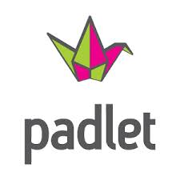
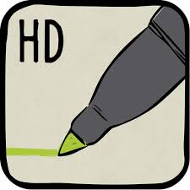 | FREE  SPACE
 | 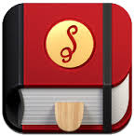

Module #4: Elementary
BLACK OUT BINGO: Once ALL Apps have been attempted and work submitted according to the link provided for each, you will receive 5 HOURS of Grant Credit! :D You will need a QR code scanner for this Module. See BACK!!
iPad App BINGO
Scan each QR Code to learn more about the App. Use the link provided to submit proof of work! Have fun with this. Let me know whenever you need help!! HAVE FUN!!!!
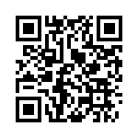  Skitch- Great App for allowing students to take pics of their work, then annotate directly over it.  http://padlet.com/wall/skitchapp | 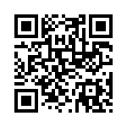  Padlet- A web tool that allows you to create a “bulletin board” for your students to send their iPad creations to.  http://padlet.com/wall/padletapp | 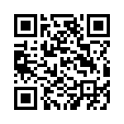  Popplet- A web tool or App that allows students to create digital mind maps.  http://padlet.com/wall/poppletapp
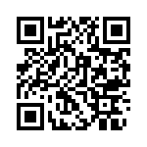  Teaching Table Lite- A math App which permits teachers to create interactive math lessons.  http://padlet.com/wall/teachingtableliteapp | FREE  SPACE | 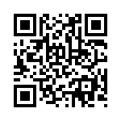  Video Scribe- Replicates the stop-motion capture style of drawing that's so popular on commercials at a fraction of the cost ($5.99). When you are ready for this app I will purchase it for you! :D  http://padlet.com/wall/videoscribeapp
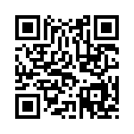  Puppet Pals HD- Create your own unique shows with animation and audio in real time!  http://padlet.com/wall/puppetpalapp | 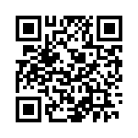  Stories on Stix- All ages will enjoy the challenge of writing stories from the ideas generated on the stix (Who, What, When, Where & Details) $1.99. When you are ready for this app I will purchase it for you! :D  Email the story to me when completed. | 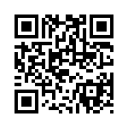  Snap Guide- Is a simple, beautiful way to share and view step-by-step how to guides.  http://padlet.com/wall/snapguideapp

