eInstruction CPS Clickers and Study Island
Objectives:
- Effectively integrate a technology device previously purchased for K-8 teachers which can make informal student assessment more engaging.
- Use eInstruction CPS clickers and Study Island together.
Instructions:
- Downloading the software
- Go to http://www.einstruction.com/ website and hover over support/download and select downloads.
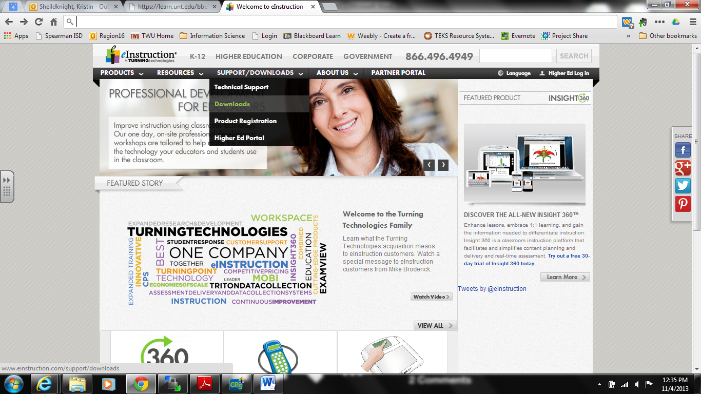

- Scroll down to CPS and find CPS Software V6.74 for Windows and select download.
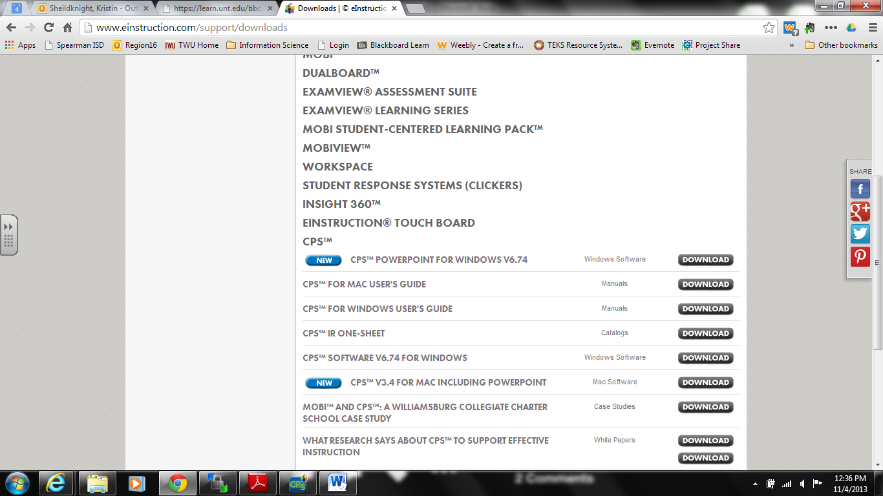
CPS V6.74 for Windows

- Go through the downloading process. This may take a few minutes!
- Once eInstruction for CPS clickers is installed, open the program from your desktop or wherever it was saved to.
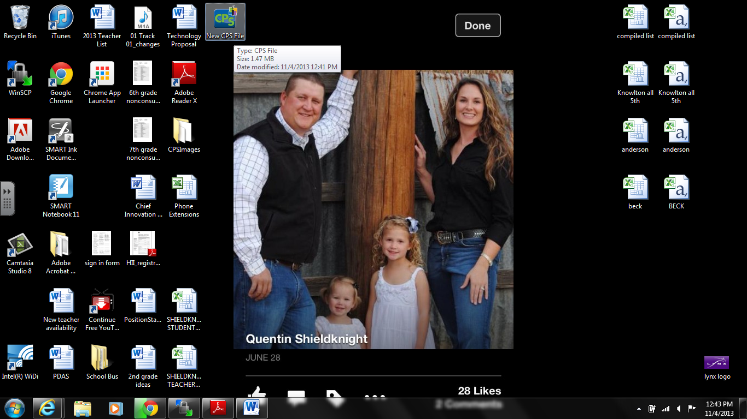
Find icon or go to programs to open.

- Creating a database
- Select Prepare then classes and students to add your students to your database.
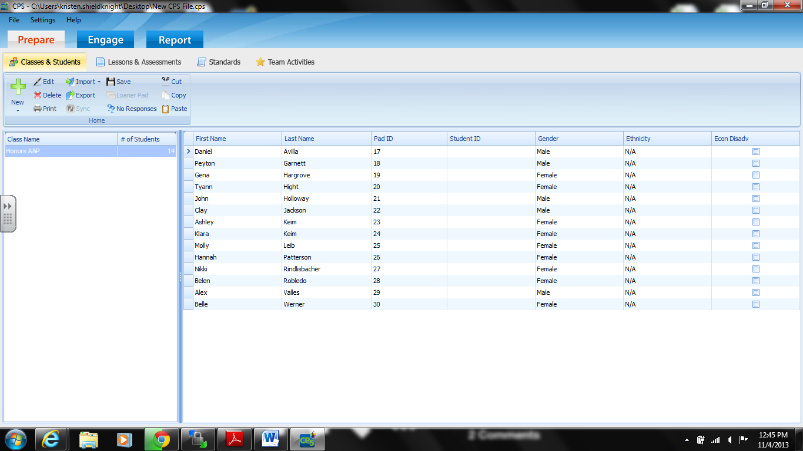
Select

- Click on the + NEW and select class.
- Select K-12 or other then hit next.
- Fill out the appropriate information.
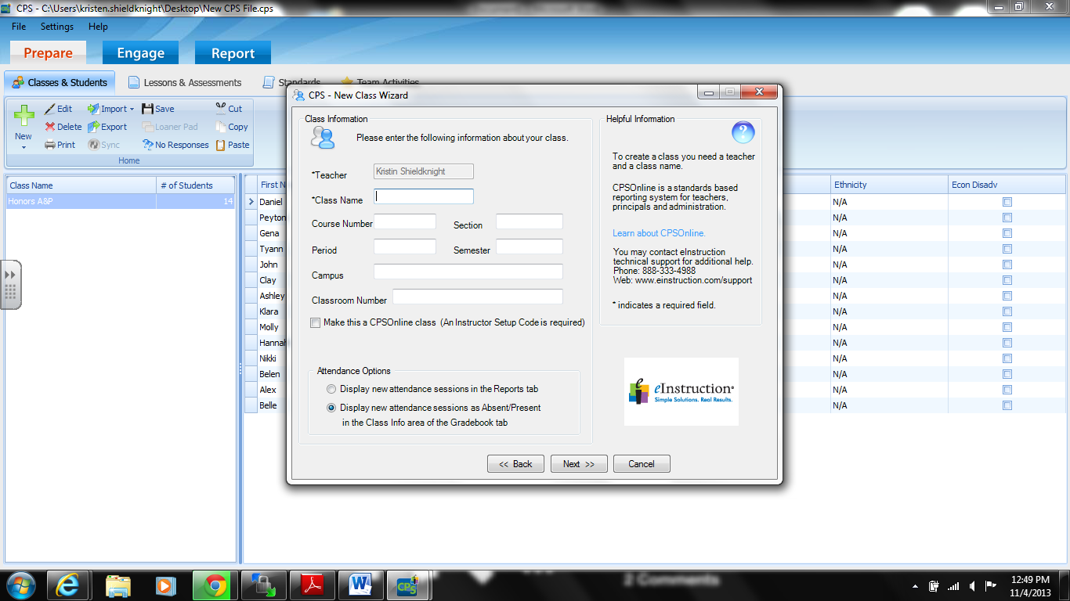
- When finished hit next. If you need to add more classes select add more classes and follow the same instructions. If not select done.
- From the list of classes you just made, select one to add students.
- Select + New and select students.
- Enter the student information. Be sure to assign them a pad #. You will use these same numbers for Study Island.
  - Select + New for each new student until all students are added to that class.
  - Continue for each class.
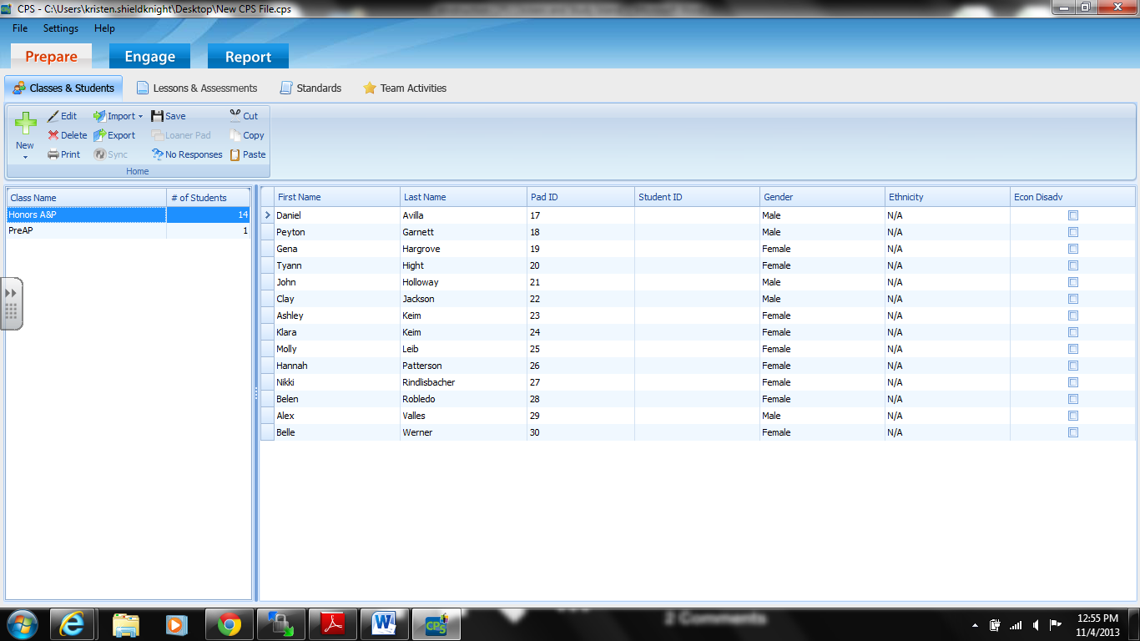

- Creating Lessons & Assessments
- Click on Lessons & Assessments from the toolbar.
- Select + NEW then folder. Name this folder appropriately for the group of lessons you will create in it.
  - You can add more folders for upcoming units but be sure to select “New CPS folder” prior to creating new folders for each unit, otherwise the folders will be categorized under the folder you last created.
- Click the folder you want to create a lesson under and select + NEW then lesson.
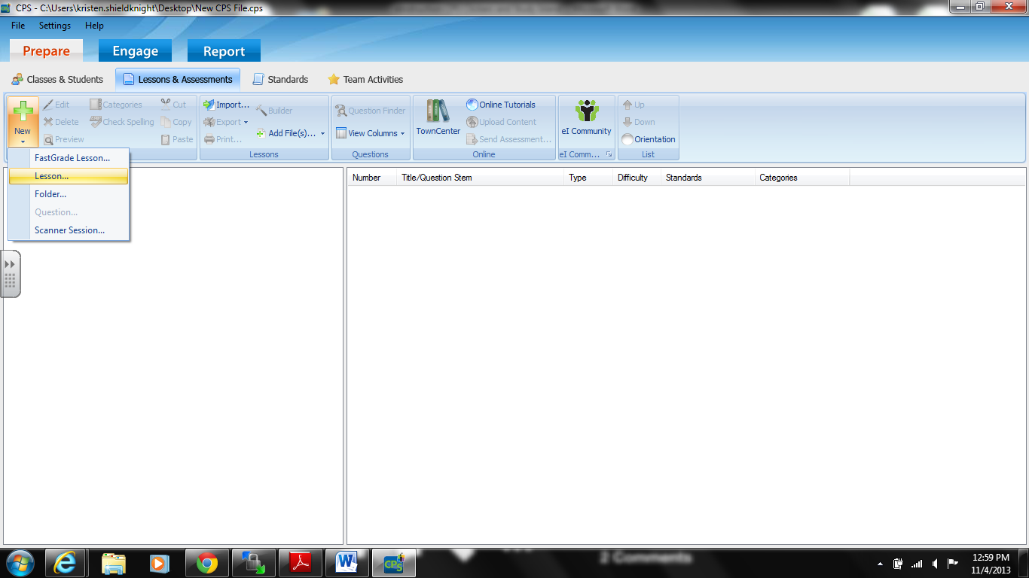
Select

- Fill out the appropriate information to identify the lesson.
  - If you have an image file you would like to associate with the lesson you may attach it as well.
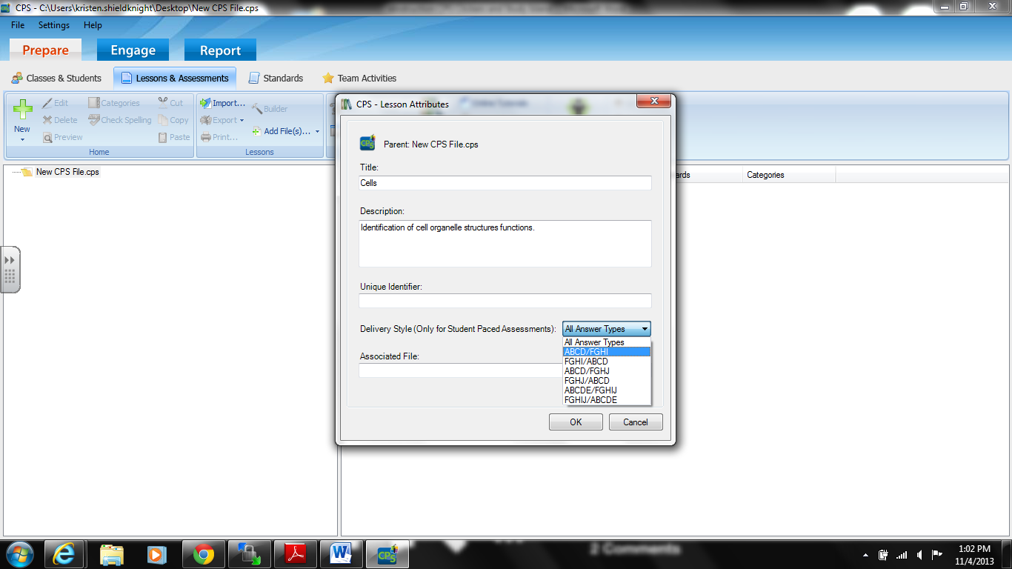
Attach file

- Adding Questions to the Lessons & Assessments
- Select the lesson title you created, then select + New and Question.
- Go to templates and select the one you want.
  - Chalkboard- permits you to “write” your questions, etc.
  - No Graphic- straight forward multiple choice question (based on your choice above)
  - Add Graphics- many options here.
    - Browse to find images you want to upload.

- Showing the Lesson
- With the correct class selected that you want to provide the lesson for, select the engage tab from the top toolbar.
- Click in the engage (play) icon to engage the lesson.
- CPS will scan for receivers
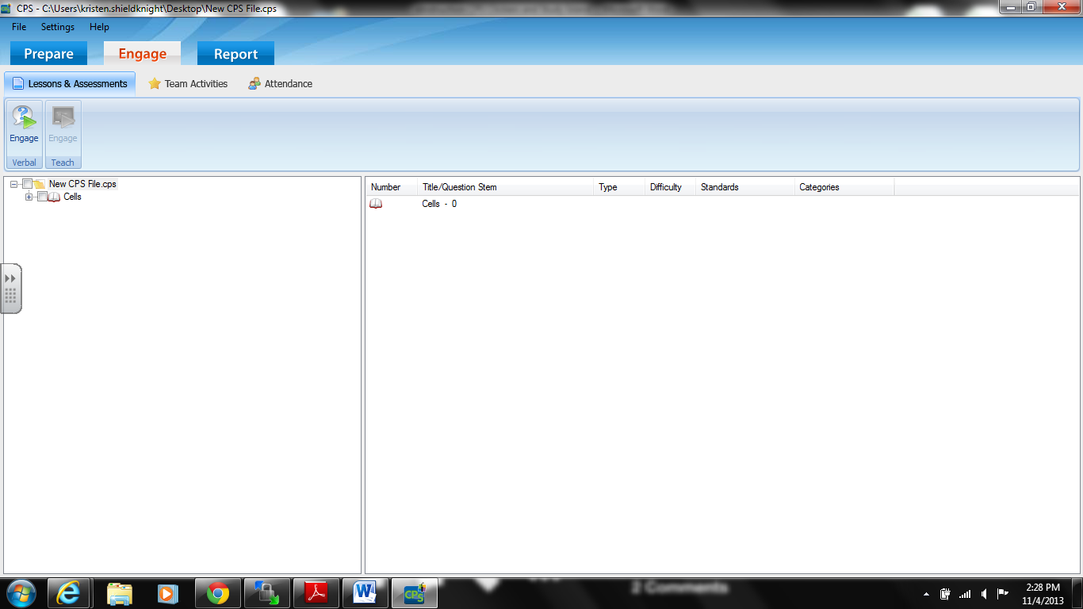
Select

- Viewing a Report/ Grades
- Click on the Report tab at the top of the page.
- Select the test and class you want to review data for.
- A list of report options appears.
  - Instructor summary- overall grade for each student
  - Response report- shows students responses with percentages
  - There are many options to explore here.

- Managing the Clickers
- Changing the Pad #’s
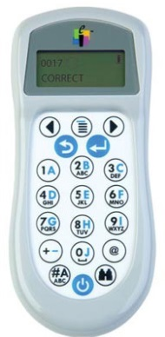
- Click the right and left arrows simultaneously, then click the + and –signs.
Right Arrow
Left Arrow
  - Ensure the correct channel is selected. Your channel can be viewed once you engage your lesson.
Plus/ minus
  - If you need to change the channel on the clickers, be sure to step away from the Bluetooth source.
  - The right arrow is your enter button.
  - Change the number of the Pad to whatever you desire. Hit the right arrow for enter.

CPS clickers and Study Island Together
- Adding Classes
- Log into Study Island at http://www.studyisland.com/web/index/
- Select class manager under My Classes on the homepage.
- Select add new class and give your class a title.
  - Select the grade you teach and select students from the list provided.
  - Add a class for each period you teach
  - Select the students you have in that particular class form the provided list and save.
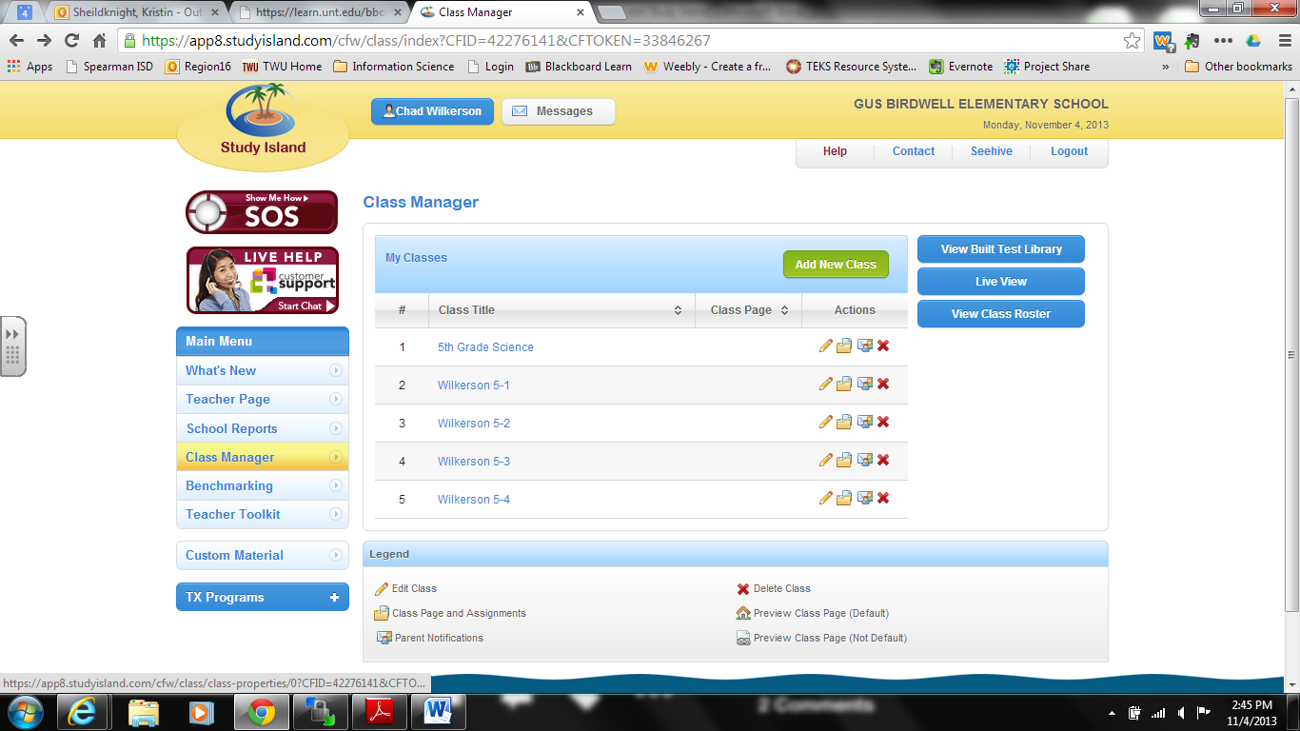
Add class
- Assigning Pad #’s
- Click on Texas Programs on the left hand side of screen.
- Select your grade.
- Select your subject.
- Select the lesson you want.
- Click on Classroom Response System and adjust the number of questions you want.
- Select no devise manager from the drop down menu then next
  - If you don’t see your eInstruction version “no devise manager” should work
  - V6.74 is not listed which is why we select no devise manager
- Select the class you need and add the Pad #’s you’ve assigned your students for the eInstruction CPS clickers.
- Select next to start the session
- You may choose teacher led or student led.
- Click Start polling to begin the session and next to move on to the next question once all your students have answered.

- Using the CPS clickers and eInstruction to grade worksheets or tests for you :D
- Select + NEW and lesson and title it appropriately.
- With the lesson selected hit + NEW and question.
  - Create your key for the worksheet, quiz, test, etc..
  - You DO NOT have to type the questions or the answers. You only have to check the correct answer choice for that question (A, B, C, D, or E).
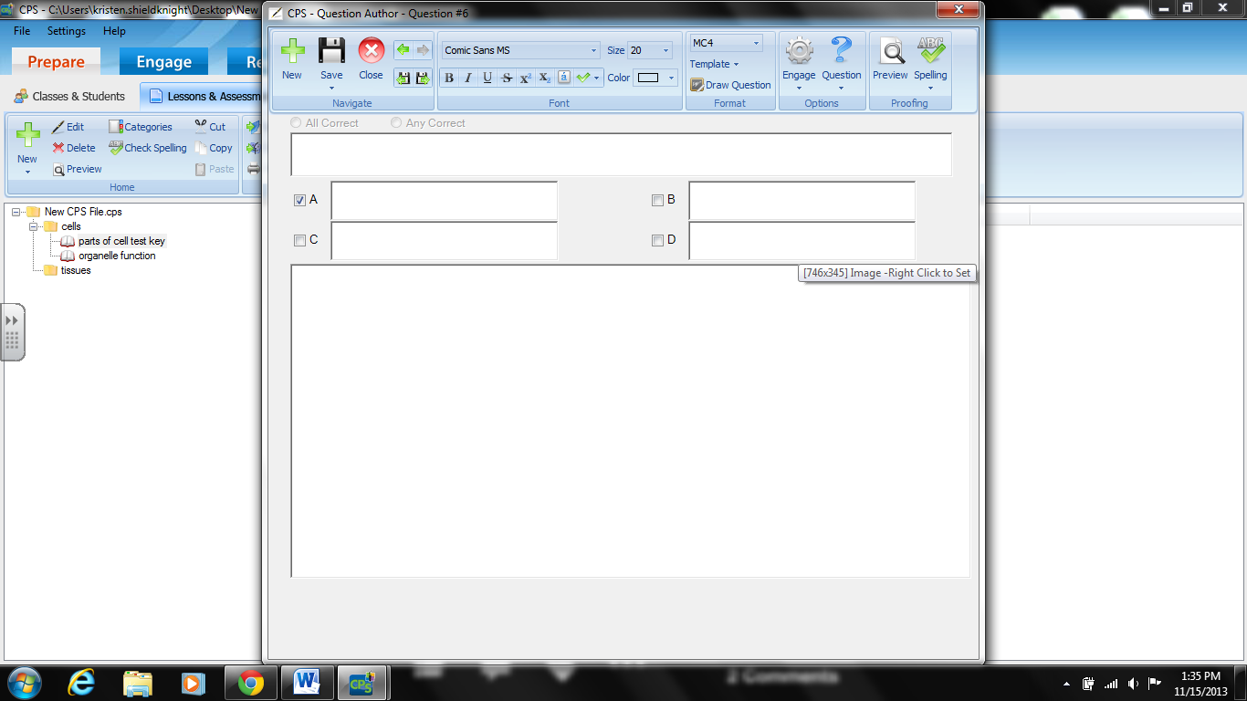
Check the correct answer.
- Click the Engage tab at the top and select the correct “test key” you created to grade your tests for you then select engage (play).
- Choose student led.

